# Technical Architecture:

Project Design Phase-II Technology Stack (Architecture & Stack)

|  |  |
| --- | --- |
| Date | 03 October 2022 |
| Team ID | PNT2022TMID51895 |
| Project Name | Project - Nutrition Assistant Application |
| Maximum Marks | 4 Marks |

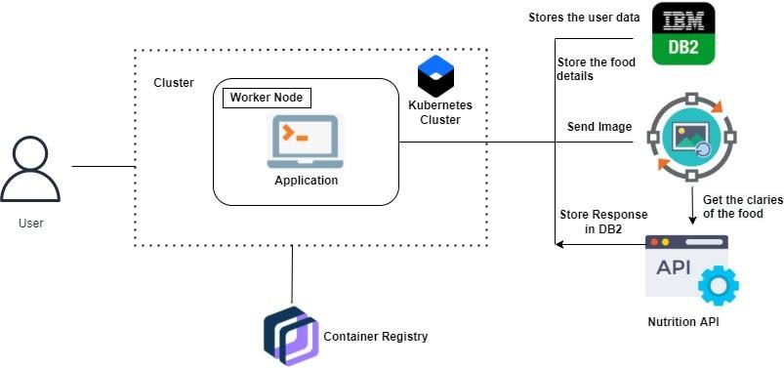

Guidelines:

1. Include all the processes (As an application logic / Technology Block)
2. Provide infrastructural demarcation (Local / Cloud)
3. Indicate external interfaces (third party API’s etc.)
4. Indicate Data Storage components / services
5. Indicate interface to machine learning models (if applicable)

# Table-1 : Components & Technologies:

|  |  |  |  |
| --- | --- | --- | --- |
| **S.No** | **Component** | **Description** | **Technology** |
| 1. | User Interface | This is a web based platform that make user feel easy to upload image and understand the application. | HTML, CSS, JavaScript , Bootstrap. |
| 2. | Application Logic-1 | Nutritional api is used to provide the nutritional  values of the food image. | Python |
| 3. | Application Logic-2 | Clarifai's AI-Driven Food Detection Model is used for accurate food identification that the user upload. | Machine Learning |
| 4. | Database | People's information, such as that of clients or users, is typically saved in databases. Databases, for instance, are used by social media platforms to store user data such as names, email addresses, and usage trends. | MySQL |
| 5. | Cloud Database | Developers, DBAs, and enterprise architects can execute real-time analytics and low-latency transactions for even the most demanding workloads thanks to IBM Db2. | IBM DB2 |
| 6. | File Storage | File storage is a hierarchical storage system used to organise and store data on a network-attached storage (NAS) device or on a computer hard drive. It is sometimes referred to as file-level storage or file-based storage. | IBM Block storage |
| 7. | External API-1 | Designing, testing, and deploying apps is made simple by the software platform known as Docker. Docker packages software into standardised units called containers, which are made up of all the necessary runtime, libraries, code, and system utilities. | Docker |

|  |  |  |  |
| --- | --- | --- | --- |
| 8. | External API-2 | The operational tasks associated with container management are automated by Kubernetes, which also includes built-in commands for application deployment, update rollout, scaling up and down to  meet changing requirements, monitoring, and other tasks. | Kubernetes |
| 9. | Infrastructure (Server / Cloud) | Application Deployment on Local System / Cloud Local Server Configuration:  Cloud Server Configuration : | Kubernetes |

**Table-2: Application Characteristics:**

|  |  |  |  |
| --- | --- | --- | --- |
| **S.No** | **Characteristics** | **Description** | **Technology** |
| 1. | Open-Source Frameworks | Flask, a Python-based framework built on Werkzeug and Jinja2, is used to construct web applications. The Flask framework has  advantages, such as a built-in development server and a rapid debugger. | Python Flask |
| 2. | Security Implementations | Securely retain user identifiers such as user name  and user details. | SHA-256, RSA |
| 3. | Scalable Architecture | Accordingly, the database can be updated. Authorized users may at any time alter the input data. | Saas |
| 4. | Availability | Because all a user needs is a smartphone with a  strong network connection, it is easily accessible. | Cloud Storage |
| 5. | Performance | Give the user the best diet plan and relevant food analysis to encourage them to eat healthily. | Python |